## C:\Users\Raja\Downloads\unnamed.pngC:\Users\Raja\Desktop\NIMO\KCG\kcg-logo.png

International Conference on Innovations& Discoveries in Science, Engineering and Technology

**17th -18th April 2018**

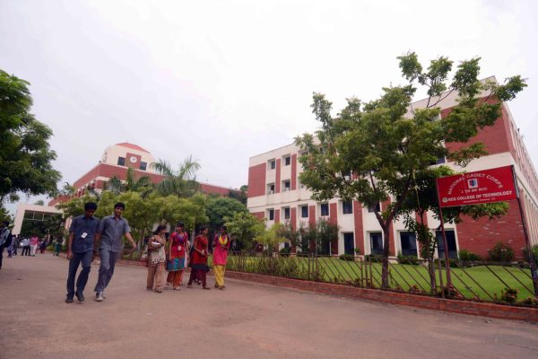(ICIDSET-18)

**Organized By**

**Research Forum**

KCG College of Technology, St. Thomas Mount,

Chennai-India – 600016

Web: www. icidset.com, Email: [icidset@gmail.com](mailto:icidset@gmail.com)

All the selected papers presented in the conference will be published in - Scopus indexed journal



**ABOUT KCG COLLEGE OF TECHNOLOGY**

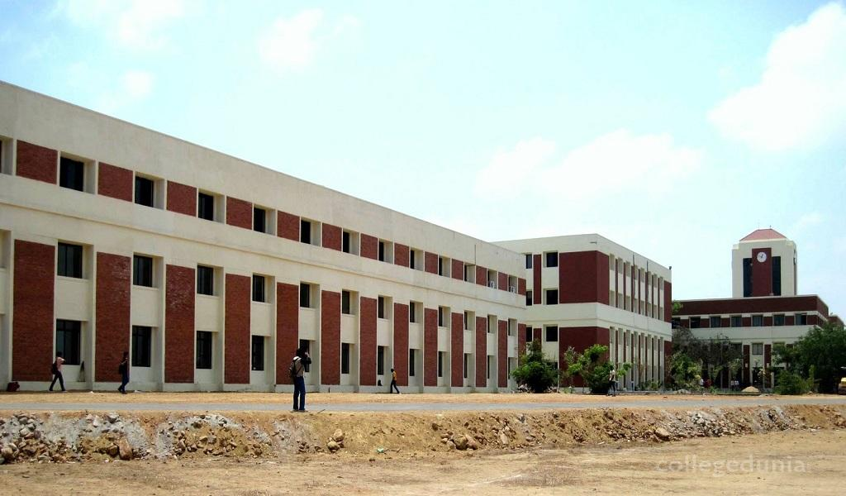 KCG College of Technology, an unit of Hindustan Group of Institutions, was established in 1988, is affiliated to Anna University Chennai and is an ISO 9001:2008 certified institution. It offers BE degree programmes in Aeronautical Engineering, Civil Engineering, Computer Science and Engineering, Electronics and Communications Engineering, Electrical and Electronics, Mechanical Engineering, Electronics and Instrumentation Engineering, B.Tech degree programme in Information Technology, M.E degree programmes in, Communication System, Computer Science and Engineering, Engineering Design, Manufacturing Engineering, Power Electronics and Drives, VLSI Design and Masters in Computer Application. Computer Science and Engineering, Electrical and Electronics Engineering, Electronics and Communication Engineering, Information Technology, Mechanical Engineering Courses of this College have been accredited by the National Board of Accreditation (NBA). Five of the departments are approved as Research Centres by Anna University to offer M.S (by Research) and Ph.D. Programmes. Six Departments have been accorded permanent affiliation by Anna University.

The campus of KCG College of Technology is beautifully landscaped in a lush green stretch of land spread over 50 acres at Karapakkam, which is about 10 km from Adyar on the Old Mahabalipuram Road, the IT corridor of Chennai. The college operates a fleet of buses connecting all parts of the city for the convenience of the students and staff.

**ABOUT LABTECH INNOVATIONS™**

Labtech Innovations™, Chennai is one of the India’s foremost and a fast growing professional association for research development and promotion in the field of Engineering, Technology & Science operating under Dexority Innovations Pvt. Ltd. Labtech Innovations™ is a paramount body which is on the track of bringing a rapid technical revolution and sustainable development in the field of Engineering, Technology & Science by facilitating knowledge flow from Institution to institution & Industry to Institution & vice versa.

The ace organization is supported by its International Advisory Board (IAB) which European to boost our organization. LABTECH is collaborated with leading technical institutes including Universities and research centers to promote the exchange of technical proceeding and research magazine.

**ABOUT THE CONFERENCE**

We are glad to announce the “International Conference on Innovations& Discoveries in Science, Engineering and Technology(ICIDSET), Chennai during 17th and 18th April 2018 in association with Labtech Innovations. All the submitted research articles will be peer-reviewed by the program and technical committees of the conference. ICIDSET-18 will provide an excellent international forum for sharing knowledge and results in Emerging Technological Innovations in Sciences, Engineering, Technology and Management. The aim of the Conference is to provide a platform to the researchers and practitioners from both academia as well as industry to meet & share the cutting-edge developments in the field of engineering technology.

**SCOPE OF THE CONFERENCE**

* All the accepted papers will be published in the conference proceedings.
* All the accepted paper will be published in relevant Scopus indexed International Journals as well as in anna university annexure I journals.
* Awards will be given for the best research paper as well as best paper presentation.
* Delegates with research activities and innovative ideas which may be beneficiary for humanities will be funded through Labtech Innovations™ Research Funding Scheme.

**CALL FOR PAPERS**

The full text paper should be in MS Word one column format (Font -Times New roman, size -12, Line spacing- 1.5)

**Original Contributions are solicited on topics covered under broad areas such as (but not limited to):**

**Electrical and Electronics Engineering**

* Renewable and sustainable energy management
* Smart Grid
* Digital Control of Electric Drives
* Recent trends in Automation
* Modern converters for industrial applications

**Electronics and Instrumentation**

* Industrial Control and Automation,
* Smart Sensors,
* Machine Vision System,
* Industrial Internet of things,
* Process Modelling and Simulation

**Aeronautical Engineering**

* Aerodynamics
* Aircraft Materials and Structures
* Aerospace Propulsion
* Avionics
* CFD
* Aircraft Maintenance
* UAV/MAV

|  |  |  |  |
| --- | --- | --- | --- |
| **IMPORTANT DATES** | March 03rd,2018 | |  |
| Paper submission : |  |
| Acceptance & Notification : | M March 10th, 2018 | |  |
| Registration and camera ready : March 20th, 2018 | |  |
| **REGISTRATION FEES** | |  |
| Researcher / Student/ Academic faculty | INR 8000/- | |  |
| Industrial Participants | INR 9000/- | |  |
| Foreign Delegates | US $300 | |  |
| Foreign Students | US $250 | |  |

Payment can be made only online (For details visit the website: www.icpiesmpae.com)

**CHIEF PATRON**

**Dr. (Mrs) Elizabeth Verghese**

Chairperson, Hindustan Group of Institutions

**Dr. Anand Jacob Verghese**

Director & CEO, Hindustan Group of Institutions

**Dr. Annie Jacob,**

Director, KCG College of Technology

**PATRON**

**Dr. G. Prabhakaran**, Principal, KCG

**Dr. Sumathi Poobal**, Vice Principal, KCG

**GENERAL CHAIR**

**Dr Bijay Ketan Panigrahi**, IIT Delhi, India

**Dr.S.S.Dash,** SRM University**,** Chennai,India

**Dr. Bijay Ketan Panigrahi,** IIT Delhi

**Dr. Deepa Jose, Head Research,** KCG

**Dr. P. Deiva Sundari, HOD/EEE,** KCG

**PROGRAM CHAIR**

**Dr. Swagatam Das**, ISI, Kolkotta

**Dr. Rajib Kar**, NIT, Duragpur

**Dr. Dash S S**, SRM University, Chennai

**PROGRAM CO-CHAIR**

**Dr. Florian Misoc**, UWM, USA

**Prof. B.Anil Kumar,** VBIT, Hyderabad

**ORGANIZING CHAIRS**

**Dr. V. Thulasi Bai,** HOD/ECE, KCG

**Dr. S. Ramesh,** HOD/MECH, KCG

**Dr. N. Bharathi**, HOD/EIE, KCG

**Dr. K. VijayaRaja**, HOD/AERO, KCG

**Dr. V. Vandhana Devi**, HOD/Civil, KCG

**Ms. M. B. Bindhu**, HOD/S&H, KCG

**ORGANIZING CO-CHAIRS**

Dr. Mayurappriyan P S

Dr. Naren Shanker R

Dr. Andal V

Dr. R Amrutha

Dr. Kanimozhimaran

Ms. B. Rammya

Mr. L. Prince Jeya Lal

Ms. Serene C Kurian

**SPECIAL SESSION CHAIR**

**Dr. Adel Nasiri**, UWM, USA

**Dr. P. N. Suganthan**, NTU, Singapore

**INTERNATIONAL/ NATIONAL ADVISORY COMMITTEE**

**Maurice Clere**, France

**Roderich Cross**, England

**Kalyanmoy Deb**, India

**Saman Halgamuge**, Australia

**Jeng-Shyang Pan,** Talwan

**Peng Shi, UK**

**Javier Del Ser,** Spain

**Leandro Dos Santos Coelho,** Brazil

**S S Pattanaik,** India

**Lingfeng Wang,** China

**K. Parsopoulos,** Greece

**Gerardo Beni,** USA

**Athanasios V. Vasilakos,** Athens

**Pei-Chann Chang,** Tawan

**Chilukuri K. Mohan,** USA

**Sacid Nahavandi,** Australia

**Abbas Khosravi,** Australia

**Almoataz Youssef Abdelaziz,** Egypt

**K.T. Chaturvedi,** India

**M.K.Tiwari,** India

**Yuhui Shi**, China

**A.Anand**, India

**Dipankar Dasagupta,** USA

**Lakshmi Jain,** Australia

**X.Z. Gao,** Finland

**Juan Luis Fernandez Martinez,** Spain

**Oscar Castillo,** Mexico

**Heitor Silveri Lopes,** Brazil

**AA Jimoh,** South Africa

**P. Sanjeevikumar**, Italy

ADDRESS FOR COMMUNICATION

**Dr.Andal/Ms. Nirmala Devi K**

**S.Derene C Kurian / Prof S.K.Thakur**

**KCG College of Technology**

#40, G.S.T Road, St. Thomas Mount, Chennai – 600 016-India

Web: www.icpiesmpae.com, E-mail: icpiesmpae@gmail.com

Mobile no: +91 9677781647, +91 9943421929,

+91 9840222892, +91 9884518242

Phone: 044-24503232/3140